1.

a. Define half adder.

A half adder is a type of adder, an electronic circuit that performs the addition of numbers. The half adder can add two single binary digits and provide the output plus a carry value.

b. Draw a truth table for the sum and carry of half adder.

|  |  |  |  |
| --- | --- | --- | --- |
| INPUT A | INPUT B | SUM | CARRY |
| 0 | 0 | 0 | 0 |
| 0 | 1 | 1 | 0 |
| 1 | 0 | 1 | 0 |
| 1 | 1 | 0 | 1 |

c. Write the sop expression from the truth table.

Sum of product =A’B+AB’

Carry of product =A.B

d. Draw the circuit using logsim.

2. a. Draw the truth table for the outputs of the full adder.

|  |  |  |  |  |
| --- | --- | --- | --- | --- |
| INPUT A | INPUT B | CARRY IN | SUM | CARRY OUT |
| 0 | 0 | 0 | 0 | 0 |
| 1 | 0 | 0 | 1 | 0 |
| 0 | 1 | 0 | 1 | 0 |
| 1 | 1 | 0 | 0 | 1 |
| 0 | 0 | 1 | 1 | 0 |
| 1 | 0 | 1 | 0 | 1 |
| 0 | 1 | 1 | 0 | 1 |
| 1 | 1 | 1 | 1 | 1 |

b. Write the corresponding sop expression for sum and carry of full

adder and simplify the expression

(A.B.C’)+(A.B’.C)+(A’.B.C)+(A.B.C)

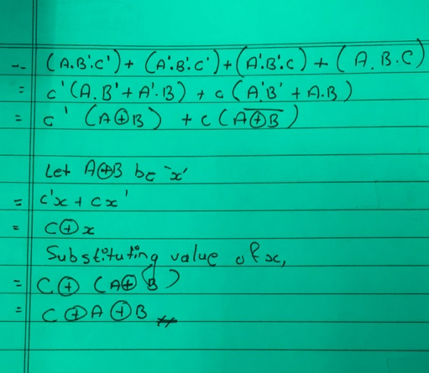

(A.B.C)+A.B’C)+(A’B.C)+(A.B.C)

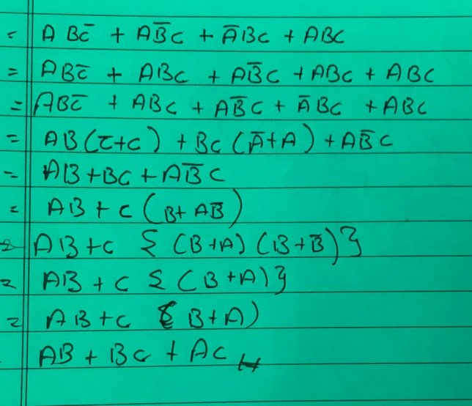

c. Draw full adder using two half adder and an OR gate.

3. Using the three stages of design, construct the circuits for the following

input /output values. Here A, B and C are the inputs whereas D, E, F, G, H

and I are outputs. Note: Draw circuit diagram using logsim corresponding

to the simplified expression of outputs D, E, F, G, H and I.

|  |  |  |  |  |  |  |  |  |
| --- | --- | --- | --- | --- | --- | --- | --- | --- |
| A | B | C | D | E | F | G | H | I |
| 0 | 0 | 0 | 1 | 0 | 1 | 0 | 1 | 1 |
| 0 | 0 | 1 | 1 | 0 | 1 | 1 | 0 | 1 |
| 0 | 1 | 0 | 1 | 0 | 1 | 1 | 1 | 1 |
| 1 | 0 | 0 | 1 | 0 | 0 | 1 | 0 | 1 |
| 1 | 1 | 1 | 1 | 1 | 1 | 1 | 1 | 1 |
| 1 | 1 | 0 | 1 | 1 | 0 | 1 | 0 | 1 |
| 1 | 0 | 1 | 1 | 1 | 1 | 1 | 1 | 0 |
| 0 | 1 | 1 | 0 | 0 | 0 | 1 | 1 | 1 |

Output: D

A+B’+C’

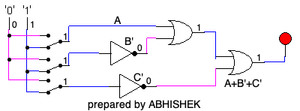

Output: E

A(C+B.C’)

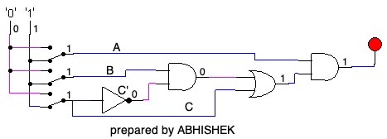

OUTPUT: F

A.C+A’.B’+A’.B.C’

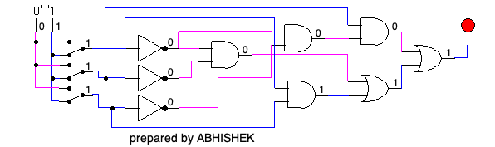

Output: G

A+B+C

Output: H

  A’.B+A.C+A’.B’.C

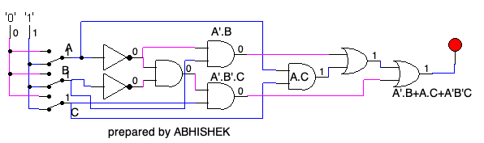

Output: I

A’+B+C’

